|  |
| --- |
|  |
| Project Management Final Project |
| Blizzard Linux Client |
|  |
|  |
|  |

|  |
| --- |
|  |

Date: April 7th, 2015

Submitted to: Philip Stubbs

Submitted by: Tyler Templeton

**Project Charter**

|  |  |  |  |
| --- | --- | --- | --- |
| **Project Title:** Blizzard Linux Client  **Project Start Date:** April 13th, 2015 **Projected Finish Date:** April 11, 2016 | | | |
| **Budget Information:** The firm has allocated $280,000 for this project. The majority of costs for this project will be internal labor. An initial estimate provides a total of 40 hours per week per worker. The remainder is used for office overhead. | | | |
| **Project Manager:** Tyler Templeton | | | |
| **Project Objectives:** To develop a client similar to the windows and Mac launcher to use on Linux | | | |
| **Approach:**   * Discuss project with Blizzard to secure legal rights to create client without cease and desist orders * Procure office and work terminals * Hire Linux security specialist to assist * Test product on test terminals * Present product to Blizzard for approval | | | |
| **Roles and Responsibilities:** | | | |
| ***Name*** | ***Role*** | ***Position*** | ***Contact Information*** |
| Michael Morhaime | Sponsor | Blizzard, CEO | N/a |
| Tyler Templeton | Project Manager | manager | templett@sheridanc.on.ca |
| Ryan Butler | Team Member | Programmer | Ryan_butler@gmail.com |
| Nicolas Leong | Team Member | Programer | Nicolas_Leong@gmail.com |
| **Comments:** “We need to be extremely careful testing this new system, especially the security in giving access to parts of the clients information in authentication.” --Michael Morhaime | | | |

Scope Statement (abbreviated)

|  |
| --- |
| **Project Title: Blizzard Linux Client**  **Date:** April 7th, 2015 **Prepared by:** Tyler Templeton templett@sheridanc.on.ca |
| **Project Justification:** We believe that there is enough of a market to bring this project to life by talking to the CEO of Blizzard Michael Morhaime in developing a Linux client for their games. With $280,000 in budget we believe we can create a product similar to the Windows and Mac versions in order to promote growth in Linux gaming and blizzards preparation of Linux's potential market increase |
| **Product Characteristics and Requirements:**   1. GUI similar to that of the windows client 2. Able to log in and authenticate 3. Ability to launch each title that the client supports 4. Ensure it has similar security as the other clients |
| **Summary of Project Deliverables**  **Project management-related deliverables:** business case, charter, team contract, scope statement, WBS, schedule, cost baseline, status reports, final project presentation, final project report, lessons-learned report, and any other documents required to manage the project.  **Product-related deliverables:**   1. Acquire legal rights to produce client from Blizzard 2. Acquire office space and terminals 3. Hire application security specialist 4. Create Linux version of Client GUI 5. Replicate code from Mac version to create similar authentication process 6. Revise code to Linux 7. Client able to log in, authenticate, and launch the games. |
| **Project Success Criteria:** Our goal is to complete this project within one year for no more than $280,000. The project sponsor Michael Morhaime, has emphasized the importance of the project paying for itself within one year after the client is complete. To meet this financial goal, the client must have the ability to log into the users profile, authenticate and launch the games allowed on its profile (Hearthstone, World of Warcraft, Starcraft 2, Diablo 3, Heroes of the Storm and if released by that time Overwatch) |

**Feasibility Study:**

**Idea Explained:**

The idea began a few months back when I came across a petition For blizzard to make a Linux client. When I first saw it had about 2000 petitioners asking for it hoping to use their preferred OS without having to use emulation measures to play their games (Wine application) which would at time kick them out for using them.

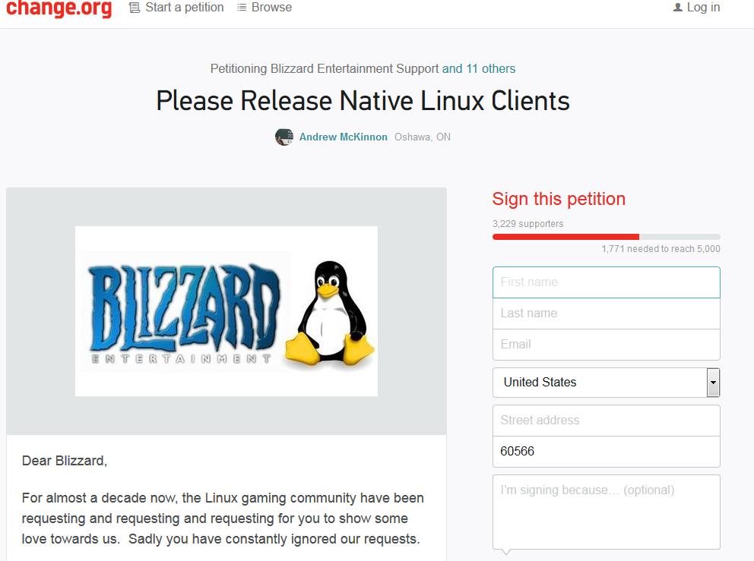

**Business Case**

**Competition:**

The only allowed competition is Blizzard themselves since they could give a cease and desist order at any groups attempting to without their expressed permission. Our first goal is to acquire rights to produce.

**Market Size:**

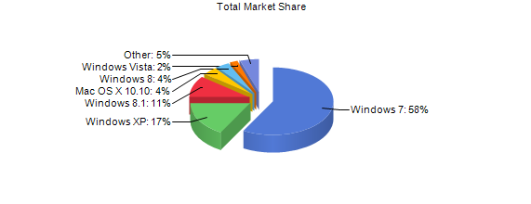

Figure Market Shares of OS from netmarketshare.com

Linix in its current stat accounts for about 2% of the desktop marketplace. With SteamOS and the increase of Linux support with games this is expected to rise over the next few years.

**Target Market**

The market is towards PC gamers ages 14- 50 years who use Linux and play Blizzard games, such as World of Warcraft and Hearthstone.

**Return on Investment**

The return on investment comes from the increased happiness of the customers which can then improve sales of games now that it is available on there preferred platform without the need for dual booting and external applications to play.

**Project plan**



1. Acquire legal rights to produce client from Blizzard

Tyler Templeton 6 hours

1. Acquire office space and terminals
2. Hire application security specialist
3. Create Linux version of Client GUI
4. Replicate code from Mac version to create similar authentication process
5. Revise code to Linux

Client able to log in, authenticate, and launch the games.

**Social Challenges:**

Social challenges would be justifying Linux as a viable platform for those who are comfortable with Windows or Mac operating systems. only with the success or failure of SteamOS and game studios continuing Linux support can truly tell us if Linux will be considered a good operating system for gaming.

**Legal challenges**

The biggest hurdle is with blizzard themselves since they have the ability to shut it down as they see fit. Assuming that we get the rights in the beginning of the project it should be smoothly developed .

**Proof of concept**